The Glocal - Change the Attitude-Change the Climate! Think Global Act Local! (2020-1-UK01-KA201-079000) is a 24-month project co funded by the Erasmus+ Programme of the European Union. The aim of the project is to make an impact on creating in-depth awareness about the climate change.
NEWS FROM THE GLOCAL PROJECT
What is it about?
The Glocal project aims to enhance Climate Change education and address key competences around the professional development of teachers and address basic skills in learners while meeting their needs in an educational programme on Climate Change. Furthermore, the project involves student mobility and offers them a chance to be involved in strategic changes. The rationale of this project was developed as part of a consensus of understanding that sustainable living is a "must" and a necessary part of today’s education offer for students from all educational sectors. The project aims to boost participants’ creativity and expression by motivating them to create powerful awareness raising messages on the current environmental situation; develop participants digital competences by using the e-learning platform; disseminate project’s results at local level by means of the "GLocal" calendar and at national and international level.
In concrete terms, we are:
- creating modules and materials for professionals and volunteers working in formal (e.g. schools) and informal (e.g. in the community) educational setting
- developing an online course to publish the above elements in the form of a MOOC (Massive Open Online Course)
- an e-book of long and short version: short version with all the executive summaries of the national chapters in English including a comparative chapter in English, and long version with chapters reflecting the findings from each participating country and written in local languages.

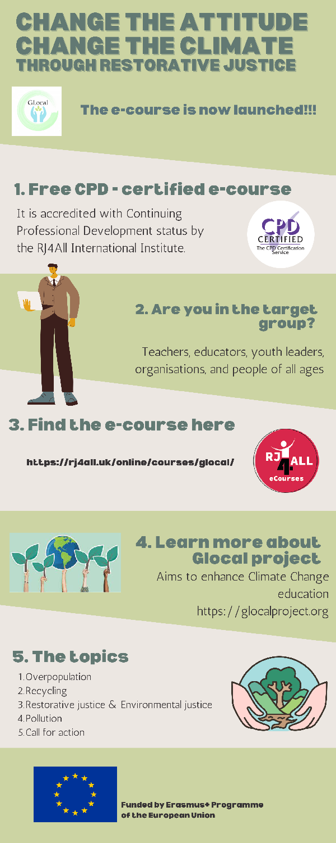
Glocal eCourse GLocal E-course: Change the Attitude - Change the Planet! Think Global - Act Local!
It introduces climate change along with its forms, the concept of restorative justice and how to effectively protect the environment. The e-course is structured around 5 modules. Each Module is composed of 4-5 Units. A module involves 2-3 hours of learning. The programme is accredited with Continuing Professional Development (CPD) status by the RJ4All International Institute. It is supplemented by the CPD certified ecourse.
https://rj4all.uk/online/courses/glocal/

The 5 educational training content modules are developed by:
1st Module Overpopulation and climate change- İ.ova Youth Art Culture Organisation,
2nd Module Recycling-Carmen,
3rd Module Restorative justice and Environmental justice- RJ4ALL
4th Module Pollution - Eruditus.
5th Module Calling for action- Lycée Beauséjour

Target Groups
We consider sustainable living is a "must" for people of all ages, so we decided to involve all levels of education: primary, secondary, high-school, and adults.
Learning principles
- Use of inquiry-based and problem-based learning approaches.
- Accommodate multiple learning styles (work and project-based learning, collaborative
- learning).
- Contextualize learning to meet the project objectives in different contexts.
- Provide authentic learning opportunities.
- Present the content in modular small chunks that will be able to provide just in time
- learning.
- Preparation of learning activities to be carried out either synchronously or
- asynchronously.
- Provision of best practices
Feedback of our TPM & Learning, Teaching Training in Romania
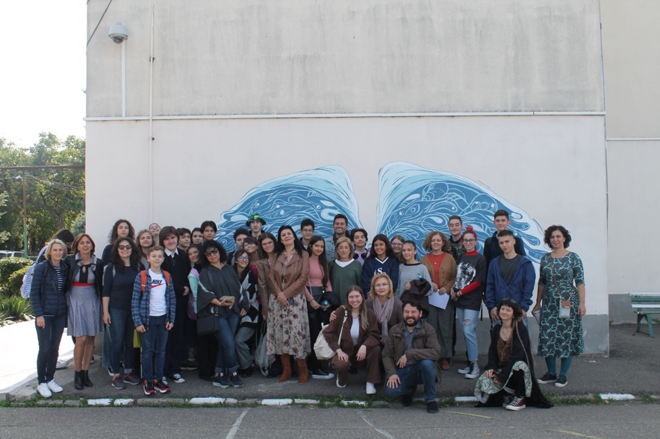
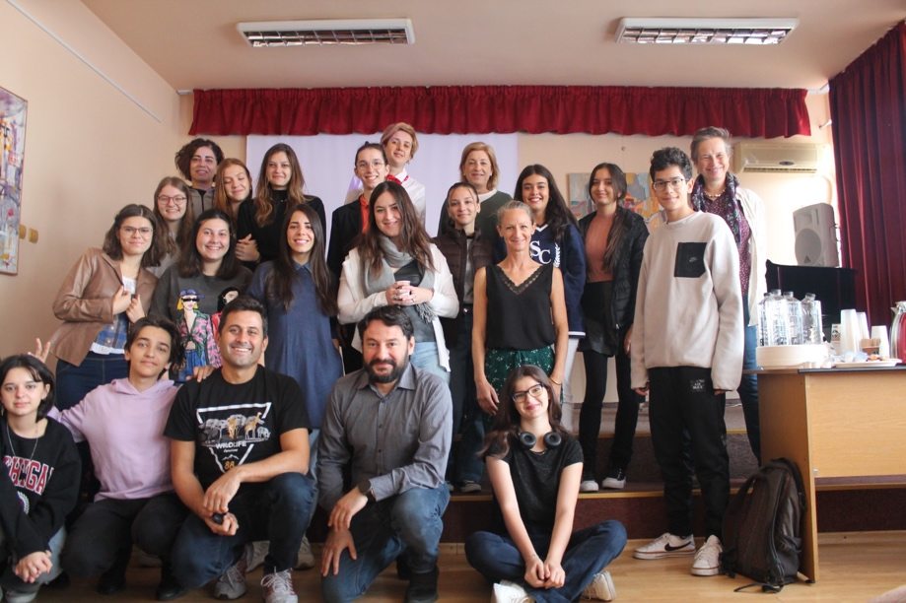
Carmen Sylva Art College organized the second Learning-Teaching-Training activity that was attended by representatives of 5 project partners: Eruditus school, RJ4ALL, Incirliova Genclik Kultur Sanat, Association Scolaire Beausejour, Inercia Digital and the host partner Carmen sylva Art College. The event took place in Ploiesti , Romania, Prahova County between 4th and 6th of October 2022. As the LTTA was also organised to present each module to the other partners, all were invited to present their work, directly in face-to-face “class” conditions. The people who were present expressed their observations and remarks, allowing final adjustments to the modules, which are now online. Each module presentation was concluded by a workshop or a participative activity.
To quantify the quality in the development of the meeting, in the adjustment to the implementation plan of the project and the expected outcomes, and in the impact on participants partner institutions, evaluation questionnaires have been filled by all participants at the end of the meeting.
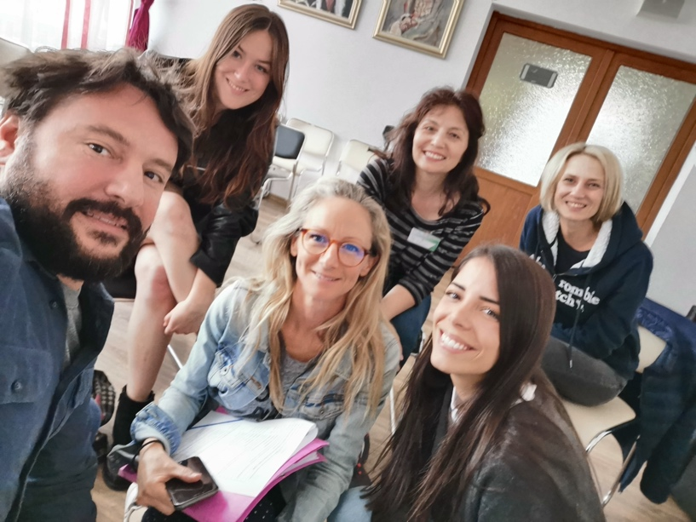

On the 3rd of October we had the chance to hold our 2nd in-person meeting in Ploiesti. It gave us the opportunity to assess the project’s progress and to further focus on its objectives.

Feedback of our Kick off TPM and Learning, Teaching Training in France
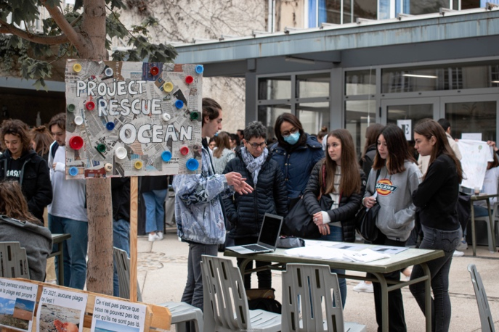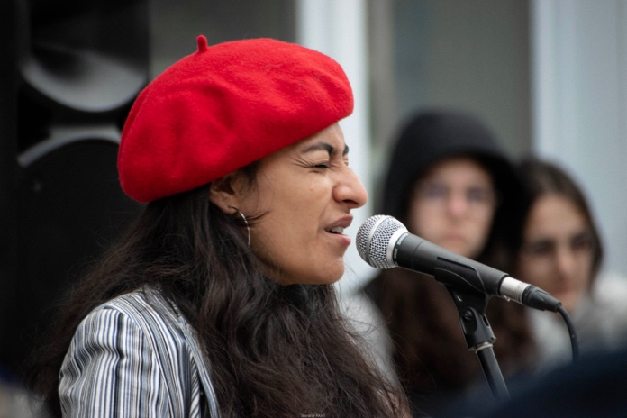

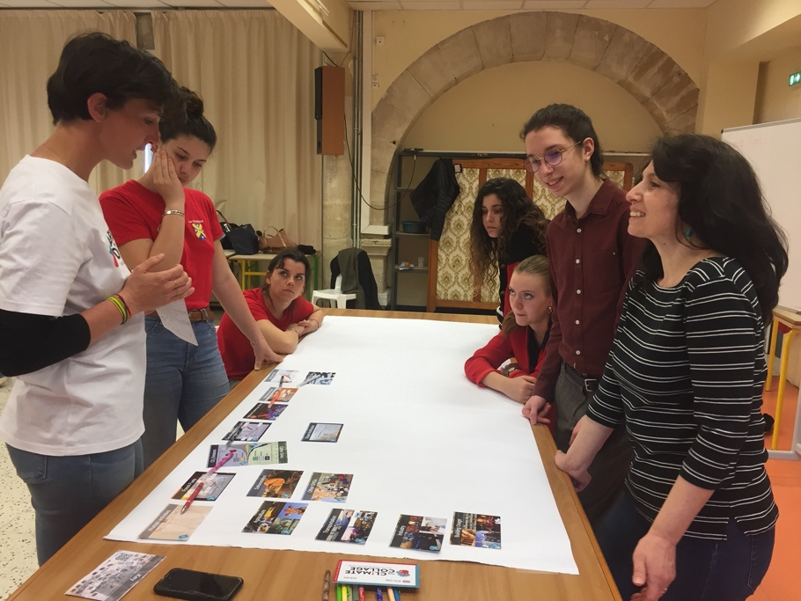
The Association Scolaire Beausejour organised the first Learning-Teaching-Training activity that was attended by representatives of four project partners: Eruditus school, RJ4ALL, Incirliova Genclik Kultur Sanat and the host partner Association Scolaire Beausejour. PartnersInercia Digital and Colegiul de Arta CARMEN attended the LTT online. The meeting was held in Narbonne on 19- 20-21st April 2022. RJ4ALL, as responsible for the evaluation, prepared a basic Google Form Survey to simplify compilation at the end of the LTT. The LTT aimed at developing participants capacity of selecting the most relevant information which was collected during the desk research conducted by partners. Throughout the LTT, participants become more aware of the actual environmental situation, get familiarized with software for digital book making, developed creative skills and strengthened key competences: communication in foreign languages (English); digital and media skills; social and civic competences as an international environment assumes attitudes and values - empathy, tolerance, collaboration, intercultural communication, respect for diversity, cohesion; encourage cultural awareness, etc.
On the 8th of November 2022 Association Scolaire Beausejour also organized first in-person meeting in Narbonne. It gave us the opportunity to assess the project’s progress, discuss on project timeline and next deliverables.

For more details on the project you can visit the Glocal website: https://glocalproject.org Click

The European Commission support for the production of this publication does not constitute an endorsement of the contents which reflects the views only of the authors, and the Commission cannot be held responsible for any use which may be made of the information contained therein.

